A service of the Colorado State Library

Funded by the Institute of Museum and Library Services (IMLS)

**Colorado Libraries Collaborate (CLC)** gives you FREE access to vast library collections around Colorado.

Members of participating libraries can borrow from any other participating library.

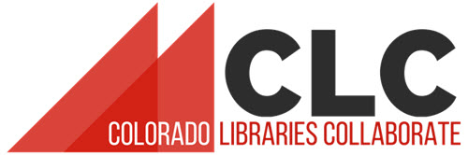

**Tips for Borrowers**

Before you visit a new library, check with them about their CLC lending policies.

Bring your library card and photo ID.

Learn more about CLC at bit.ly/colibcollab

YOUR LIBRARY LOGO HERE

A service of the Colorado State Library

Funded by the Institute of Museum and Library Services (IMLS)

**Colorado Libraries Collaborate (CLC)** gives you FREE access to vast library collections around Colorado.

Members of participating libraries can borrow from any other participating library.



**Tips for Borrowers**

Before you visit a new library, check with them about their CLC lending policies.

Bring your library card and photo ID.

Learn more about CLC at bit.ly/colibcollab

YOUR LIBRARY LOGO HERE